IT2120 - Probability and Statistics

Name: Louis E.S

IT No: IT24100701

Exercise 1

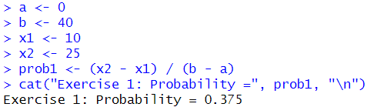

Exercise 2

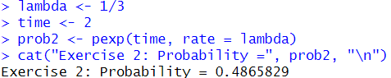

Exercise 3

